**INDIAN INSTITUTE OF INFORMATION TECHNOLOGY, SONEPAT**



**Application programming practical file**

**Name :Siddhant Dev Mannu**

**Branch :IT**

**Roll No :11912077**

**SESSION 2020-2021 (SEMESTER-2)**

**INDEX**

|  |  |  |
| --- | --- | --- |
| **S.NO** | **PROGRAMS** | **PAGE NO** |
| **1.** | **Creating an HTML Web page forms.** | **3-7** |
| **2.** | **Creating Home Page using HTML.** | **8-13** |
| **3.** | **Creating XHTML and CSS and understanding its use in creating web pages.** | **14-18** |
| **4.** | **Setting up and configuration of Apache Tomcat server.** | **19-20** |
| **5.** | **Understanding modification on Web.XML.** | **21-23** |
| **6.** | **Creating a Website using PHP.** | **24-33** |
| **7.** | **Understanding java script.** | **34-35** |
| **8.** | **Creating Web page with back end in PHP and front end in Java script and hosting it on Apache Tomcat server.** | **35-39** |

1. **Aim: Creating an HTML Web page forms.**

**CODE:**

<!DOCTYPE html>

<html>

<head>

<title>Registration Form</title>

<style>

body

{

background-image: radial-gradient(circle, blue, yellow);

background-image: radial-gradient ();

}

.main_class

{

background-color: beige;

margin:10px 300px;

border:2px solid black;

border-radius: 10px;

}

.heading

{

position: relative;

margin-top: 15px;

margin-left: 40px;

margin-right: 40px;

border:2px solid black;

background-color: chartreuse;

text-align: center;

border-radius: 40px;

}

.title

{

margin-left: 60px;

font-family: sans-serif;

font-display: auto;

font-size: 20px;

}

.submit

{

background-color: antiquewhite;

position: relative;

border-radius: 20px;

margin: 0px 40px;

padding: 10px 240px;

margin-top: 30px;

}

.submit1

{

background-color: palevioletred;

border: 2px solid black;

border-radius:25px;

color: white;

padding: 10px 20px;

text-align: center;

text-decoration: none;

display: inline-grid;

font-size: 16px;

margin: 4px 4px;

cursor: pointer;

}

</style>

</head>

<body>

<div class="main_class">

<div class="heading">

<h2><b>Registration Form</b></h2>

</div>

<br>

<br>

<div class="title">

<label>First Name:</label>

<input type="text"><br><br>

</div>

<div class="title">

<label>Last Name:</label>

<input type="text"><br><br>

</div>

<div class="title">

<label>Gender:</label>

<input type="radio" name="Gender">

<label>Male</label>

<input type="radio" name="Gender">

<label>Female</label>

<input type="radio" name="Gender">

<label>Other</label>

</div><br>

<div class="title">

<label>Cast: </label>

<input type="radio" name="cast">

<label>GENERAL</label>

<input type="radio" name="cast">

<label>OBC</label>

<input type="radio" name="cast">

<label>SC</label>

<input type="radio" name="cast">

<label>ST</label>

</div><br>

<div class="title">

<label>E-mail:</label>

<input type="email" name="email" placeholder="xyz@gmail.com">

</div><br>

<div class="title">

<label>Phone No:</label>

<input type="tel" name="phone" placeholder="0123-456-789">

</div><br>

<div class="title">

<label>Password:</label>

<input type="password" name="password" placeholder="******">

</div>

<br>

<div class="title">

<label>Confirm Password:</label>

<input type="password" name="password" placeholder="******">

</div>

<div class="submit">

<div class="submit1">

<input type="submit" value="Submit Form">

<input type="reset" value="Clear Form"></div>

</div>

</form>

</div>

</body>

</html>

**OUTPUT:**

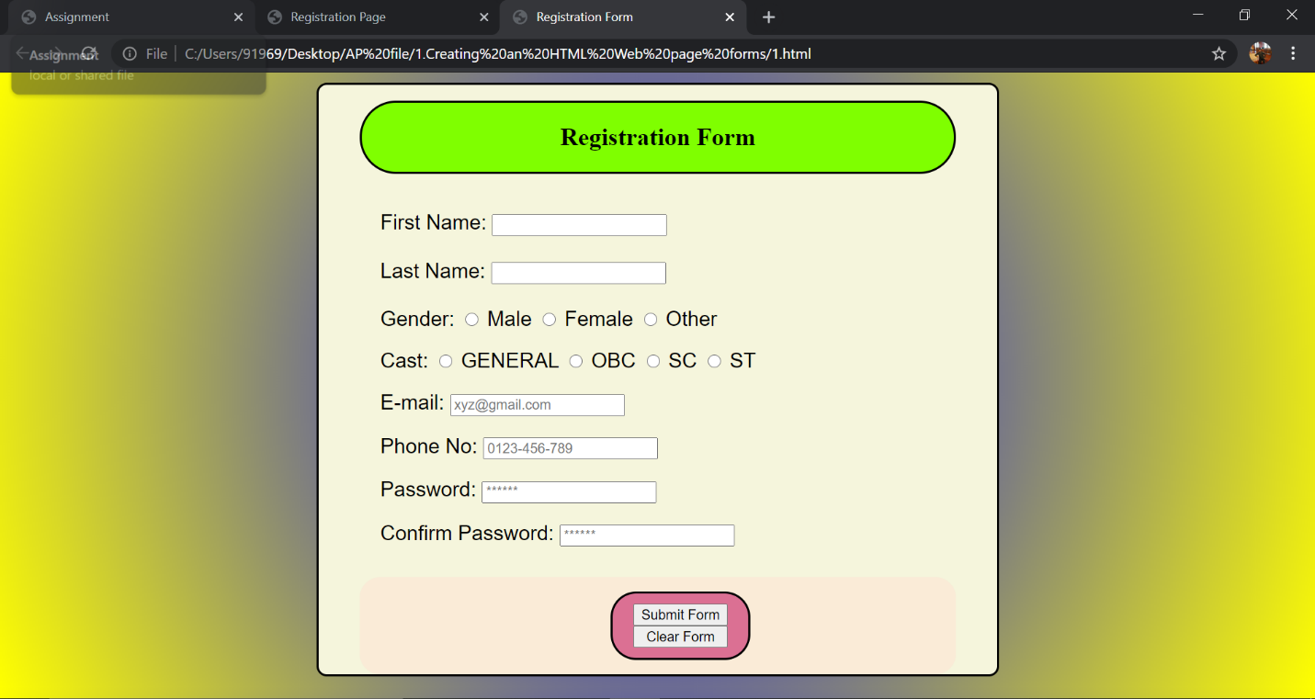

1. **Aim: Creating Home Page using HTML.**

**CODE:**

1. **homepage.html**

<!DOCTYPE html>

<html>

<head>

<title>Assignment</title>

</head>

<frameset rows="20%,60%,20%">

<frame src="top.html">

<frame src="a.html">

<frame src="b.html">

</frameset>

<body>

</body>

</html>

1. **top.html**

<!DOCTYPE html>

<html>

<head>

<style>

h3.top

{

color: black;

margin:5;

padding: 0px 5px;

text-decoration: underline;

}

body

{

background-color: antiquewhite;

background-size: cover;

background-position: fixed;

}

h3 top

{

position: absolute;

top:50%;

left:50%;

transform: translate(-50%,-50%);

background-color: antiquewhite;

}

</style>

</head>

<body>

<h3 class="top">INDIAN INSTITUTE OF INFORMATION TECHNOLOGY,SONEPAT<img src="logo1.jpg" width="50px" height="50px">भारतीय सूचना प्रौद्योगिकी संस्थान , सोनीपत

</h3>

</body>

</html>

1. **left.html**

<!DOCTYPE html>

<html>

<head>

<title></title>

<style type="text/css">

body

{

background-image: linear-gradient(90deg, yellow, #B0C4DE)

}

h1{

color: blue;

font-size: 45px

}

</style>

</head>

<body>

<h2>Name: Siddhant Dev Mannu</h2><br>

<h2>Branch: IT</h2><br>

<h2>Roll No: 11912077</h2><br>

</body>

</html>

1. **right.html**

<!DOCTYPE html>

<html>

<head>

<title></title>

<style type="text/css">

body

{

background-color: darkorange;

background-image: linear-gradient(90deg,light blue,#B0C4DE)

}

h1{

color: blue;

font-size: 45px

}

</style>

</head>

<body>

<h1>APPLICATION PROGRAMMING</h1>

</body>

</html>

1. **a.html**

<!DOCTYPE html>

<html>

<head>

<title></title>

</head>

<frameset cols="30%,40%,30%">

<frame src="left.html"></frame>

<frame src="logo.html">

<frame src="right.html">

</frameset>

<body>

</body>

</html>

1. **b.html**

<!DOCTYPE html>

<html>

<head>

<style>

h4.h

{

color: red;

position: absolute;

top:5%;

left:50%;

transform: translate(-50%,-50%);

}

body

{

background-color: midnightblue;

}

p.p{

color: aliceblue;

}

.l

{

text-align-last: right;

color: hotpink;

}

</style>

</head>

<body>

<h4 class="h">CONTACT DETAILS</h4><br/>

<p class="p"><b>phone no :**********</b></p>

<p class="p"><b>email id:xyz@gmail.com</b></p>

<p class="l"><b>Page Designed By: Siddhant Dev Mannu</b></p>

</body>

</html>

1. logo.html

<!DOCTYPE html>

<html>

<head>

<title></title>

</head>

<body align="center">

<img src="logo.png" height="340" width="480">

</body>

</html>

**OUTPUT:**

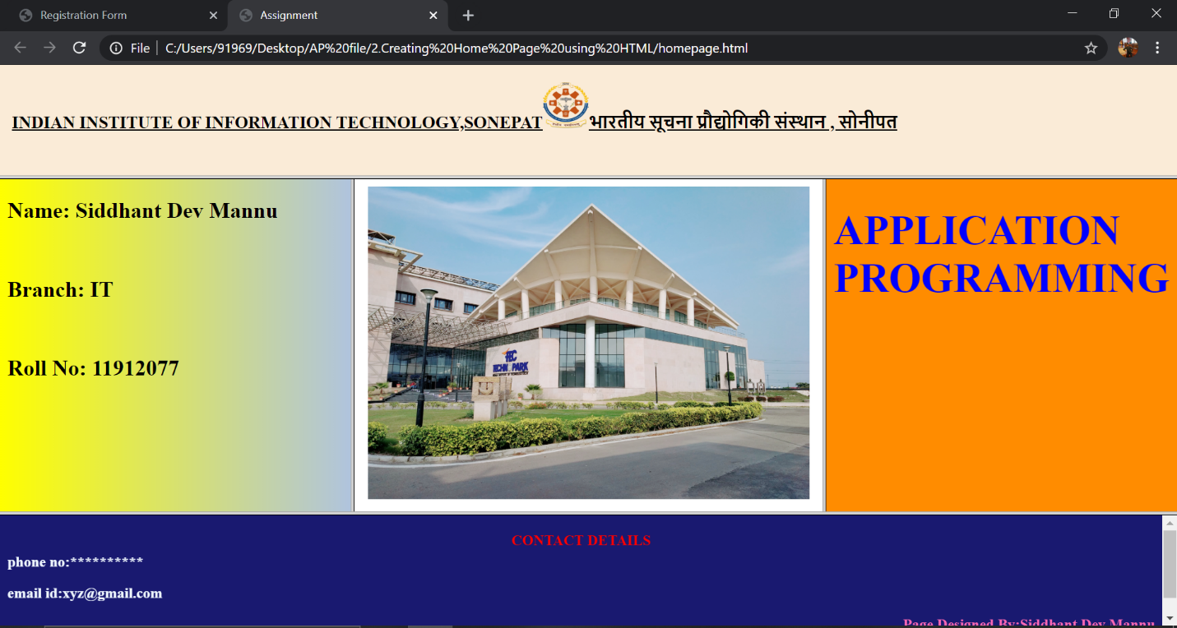

1. **Aim: Creating XHTML and CSS and understanding its use in creating web pages.**

**CODE:**

1. **3.html**

<!DOCTYPE html PUBLIC "-//W3C//DTD XHTML 1.1//EN"

"http://www.w3.org/TR/xhtml11/DTD/xhtml.dtd">

<html lang="en" dir="ltr">

<head>

<title>Registration Page</title>

<link rel="stylesheet" type="text/css" href="text.css">

<style>

body

{

background-color: aliceblue;

}

</style>

</head>

<body>

<div class="main_class">

<div class="heading">

<h2><b>Registration Form</b></h2>

</div>

<br>

<br>

<div class="title">

<label>Username:</label>

<input type="text"><br><br>

</div>

<div class="title">

<label>E-mail:</label>

<input type="email" name="email" placeholder="xyz@gmail.com">

</div><br>

<div class="title">

<label>Phone No:</label>

<input type="tel" name="phone" placeholder="0123-456-789">

</div><br>

<div class="title">

<label>Gender:</label>

<input type="radio" name="Gender">

<label>Male</label>

<input type="radio" name="Gender">

<label>Female</label>

<input type="radio" name="Gender">

<label>Other</label>

</div><br>

<div class="title">

<label>Cast: </label>

<input type="radio" name="cast">

<label>GENERAL</label>

<input type="radio" name="cast">

<label>OBC</label>

<input type="radio" name="cast">

<label>SC</label>

<input type="radio" name="cast">

<label>ST</label>

</div><br>

<div class="submit">

<div class="submit_css">

<input type="submit" value="Submit Form">

</div>

</form>

</div>

</body>

</html>

1. **text.css**

*{

background-image: radial-gradient();

}

.main_class

{

background-color: aquamarine;

margin:10px 300px;

border:2px solid black;

border-radius: 20px;

}

.heading

{

position: relative;

margin-top: 15px;

margin-left: 40px;

margin-right: 40px;

border:2px solid black;

background-color: crimson;

text-align: center;

border-radius: 0px;

}

.title

{

margin-left: 60px;

font-family: sans-serif;

font-display: auto;

font-size: 20px;

}

.submit

{

background-color: antiquewhite;

position: relative;

border-radius: 20px;

margin: 0px 40px;

padding: 10px 240px;

margin-top: 30px;

}

.submit_css{

background-color: palevioletred;

border: 2px solid black;

border-radius:25px;

color: white;

padding: 10px 20px;

text-align: center;

text-decoration: none;

display: inline-grid;

font-size: 16px;

margin: 4px 4px;

cursor: pointer;

}

**OUTPUT:**

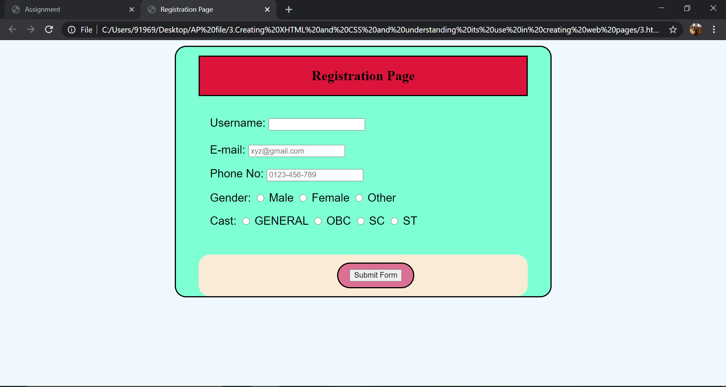

1. **Aim: Setting up and configuration of Apache Tomcat server.**

**CODE:**

1. **Web.xml**

Step by Step Guide to Setup and Install Apache Tomcat Server in Eclipse Development Environment (IDE)

Last Updated on August 4th, 2018 by App Shah 69 comments

Eclipse is a very powerful development environment for Java. Mainly for Web Development project you need Web Server. Apache Tomcat is the best production ready web container.

By default when you download Eclipse IDE, it doesn’t come with Tomcat install with it. In this tutorial we will go over all detailed steps to configure Apache Tomcat successfully in Eclipse environment.

Have any of below questions? Then you are at right place.

Configuration of the Eclipse Workspace and Apache Tomcat

How can I add Tomcat server to eclipse?

Installing Apache Tomcat Server – Eclipse

Tutorial: Configuring and Using Apache Tomcat 9 with Eclipse

Apache Tomcat Eclipse Integration Guide & Plugin

how to add apache tomcat server in eclipse Photon?

Step-1

Download Apache Tomcat from this link. I’m using version 9.0.10.

Download Apache Tomcat 9 Version - Crunchify Tips

Step-2

Extract it to Document folder.

Extract Apache Tomcat To Document Folder

Step-3

Open Eclipse Environment

Click on Servers Tab

Click on No servers are available. Click this link to create a new server...

Click Tomcat v9.0 Server and Next

Choose Eclipse, Server Tab, Add Server, Select Apache Tomcat

Step-4

Select Apache installation Directory and click Finish.

Add new Apache Tomcat Server in Eclipse

Step-5

You should see Tomcat v9.0 Server at localhost [Stopped, Republish] under Servers tab. Double click on it verify HTTP ports information. By default HTTP port is 8080.

Apache Tomcat 8 HTTP Port 8080

Step-6

Now right click on Server and click Start.

Start Apache Tomcat in Eclipse - Crunchify Tips

Console output:

Aug 04, 2018 11:12:57 AM org.apache.catalina.startup.VersionLoggerListener log

INFO: Server version: Apache Tomcat/9.0.10

INFO: OS Name: Mac OS X

INFO: OS Version: 10.13.6

INFO: Architecture: x86_64

INFO: Java Home: /Library/Java/JavaVirtualMachines/jdk-10.0.2.jdk/Contents/Home

INFO: JVM Version: 10.0.2+13

INFO: JVM Vendor: "Oracle Corporation"

INFO: CATALINA_BASE: /Users/appshah/Documents/jee-photon/workspace/c/.metadata/.plugins/org.eclipse.wst.server.core/tmp0

INFO: CATALINA_HOME: /Users/appshah/Documents/jee-photon/apache-tomcat-9.0.10

INFO: Command line argument: -Dcatalina.base=/Users/appshah/Documents/jee-photon/workspace/c/.metadata/.plugins/org.eclipse.wst.server.core/tmp0

INFO: Command line argument: -Dcatalina.home=/Users/appshah/Documents/jee-photon/apache-tomcat-9.0.10

INFO: Command line argument: -Dwtp.deploy=/Users/appshah/Documents/jee-photon/workspace/c/.metadata/.plugins/org.eclipse.wst.server.core/tmp0/wtpwebapps

INFO: Command line argument: -Dfile.encoding=UTF-8

INFO: The APR based Apache Tomcat Native library which allows optimal performance in production environments was not found on the java.library.path: [/Users/appshah/Library/Java/Extensions:/Library/Java/Extensions:/Network/Library/Java/Extensions:/System/Library/Java/Extensions:/usr/lib/java:.]

INFO: Initializing ProtocolHandler ["http-nio-8080"]

INFO: Using a shared selector for servlet write/read

INFO: Initializing ProtocolHandler ["ajp-nio-8009"]

INFO: Using a shared selector for servlet write/read

INFO: Initialization processed in 1946 ms

INFO: Starting service [Catalina]

INFO: Starting Servlet Engine: Apache Tomcat/9.0.10

INFO: At least one JAR was scanned for TLDs yet contained no TLDs. Enable debug logging for this logger for a complete list of JARs that were scanned but no TLDs were found in them. Skipping unneeded JARs during scanning can improve startup time and JSP compilation time.

WARNING: Creation of SecureRandom instance for session ID generation using [SHA1PRNG] took [262] milliseconds.

INFO: Starting ProtocolHandler ["http-nio-8080"]

INFO: Starting ProtocolHandler ["ajp-nio-8009"]

INFO: Server startup in 1655 ms

It should be up and running on port 8080 and you could visit default page using URL: <http://localhost:8080/>

1. **Understanding modification on Web.XML.**

**CODE:**

<?xml version="1.0" encoding="UTF-8"?>

<!--

Licensed to the Apache Software Foundation (ASF) under one or more

contributor license agreements. See the NOTICE file distributed with

this work for additional information regarding copyright ownership.

The ASF licenses this file to You under the Apache License, Version 2.0

(the "License"); you may not use this file except in compliance with

the License. You may obtain a copy of the License at

http://www.apache.org/licenses/LICENSE-2.0

Unless required by applicable law or agreed to in writing, software

distributed under the License is distributed on an "AS IS" BASIS,

WITHOUT WARRANTIES OR CONDITIONS OF ANY KIND, either express or implied.

See the License for the specific language governing permissions and

limitations under the License.

-->

<web-app xmlns="http://xmlns.jcp.org/xml/ns/javaee"

xmlns:xsi="http://www.w3.org/2001/XMLSchema-instance"

xsi:schemaLocation="http://xmlns.jcp.org/xml/ns/javaee

http://xmlns.jcp.org/xml/ns/javaee/web-app_3_1.xsd"

version="3.1">

<!-- ======================== Introduction ============================== -->

<!-- This document defines default values for *all* web applications -->

<!-- loaded into this instance of Tomcat. As each application is -->

<!-- deployed, this file is processed, followed by the -->

<!-- "/WEB-INF/web.xml" deployment descriptor from your own -->

<!-- applications. -->

<!-- -->

<!-- WARNING: Do not configure application-specific resources here! -->

<!-- They should go in the "/WEB-INF/web.xml" file in your application. -->

<!-- ================== Built In Servlet Definitions ==================== -->

<!-- The default servlet for all web applications, that serves static -->

<!-- resources. It processes all requests that are not mapped to other -->

<!-- servlets with servlet mappings (defined either here or in your own -->

<!-- web.xml file). This servlet supports the following initialization -->

<!-- parameters (default values are in square brackets): -->

<!-- -->

<!-- debug Debugging detail level for messages logged -->

<!-- by this servlet. Useful values are 0, 1, and -->

<!-- 11 where higher values mean more detail. [0] -->

<!-- -->

<!-- fileEncoding Encoding to be used to read static resources -->

<!-- [platform default] -->

<!-- -->

<!-- useBomIfPresent If a static file contains a byte order mark -->

<!-- (BOM), should this be used to determine the -->

<!-- file encoding in preference to fileEncoding. -->

<!-- [true] -->

<!-- -->

<!-- input Input buffer size (in bytes) when reading -->

<!-- resources to be served. [2048] -->

<!-- -->

<!-- listings Should directory listings be produced if there -->

<!-- is no welcome file in this directory? [false] -->

<!-- WARNING: Listings for directories with many -->

<!-- entries can be slow and may consume -->

<!-- significant proportions of server resources. -->

<!-- -->

<!-- output Output buffer size (in bytes) when writing -->

<!-- resources to be served. [2048] -->

<!-- -->

<!-- readonly Is this context "read only", so HTTP -->

<!-- commands like PUT and DELETE are -->

<!-- rejected? [true] -->

<!-- -->

<!-- readmeFile File to display together with the directory -->

<!-- contents. [null] -->

<!-- -->

<!-- sendfileSize If the connector used supports sendfile, this -->

<!-- represents the minimal file size in KB for -->

<!-- which sendfile will be used. Use a negative -->

<!-- value to always disable sendfile. [48] -->

<!-- -->

<!-- useAcceptRanges Should the Accept-Ranges header be included -->

<!-- in responses where appropriate? [true] -->

<!-- -->

<!-- For directory listing customization. Checks localXsltFile, then -->

<!-- globalXsltFile, then defaults to original behavior. -->

<!-- -->

<!-- localXsltFile Make directory listings an XML doc and -->

<!-- pass the result to this style sheet residing -->

<!-- in that directory. This overrides -->

<!-- contextXsltFile and globalXsltFile[null] -->

<!-- -->

<!-- contextXsltFile Make directory listings an XML doc and -->

<!-- pass the result to this style sheet which is -->

<!-- relative to the context root. This overrides -->

<!-- globalXsltFile[null] -->

<!-- -->

<!-- globalXsltFile Site wide configuration version of -->

<!-- localXsltFile. This argument must either be an -->

<!-- absolute or relative (to either -->

<!-- $CATALINA_BASE/conf or $CATALINA_HOME/conf) -->

<!-- path that points to a location below either -->

<!-- $CATALINA_BASE/conf (checked first) or -->

<!-- $CATALINA_HOME/conf (checked second).[null] -->

<!-- -->

<!-- showServerInfo Should server information be presented in the -->

<!-- response sent to clients when directory -->

<!-- listings is enabled? [true] -->

<!-- -->

<!-- allowPartialPut Should the server treat an HTTP PUT request -->

<!-- with a Range header as a partial PUT? Note -->

<!-- that RFC 7233 clarified that Range headers are -->

<!-- only valid for GET requests. [true] -->

<servlet>

<servlet-name>default</servlet-name>

<servlet-class>org.apache.catalina.servlets.DefaultServlet</servlet-class>

<init-param>

<param-name>debug</param-name>

<param-value>0</param-value>

</init-param>

<init-param>

<param-name>listings</param-name>

<param-value>true</param-value>

</init-param>

<load-on-startup>1</load-on-startup>

</servlet>

1. **Web.xml**

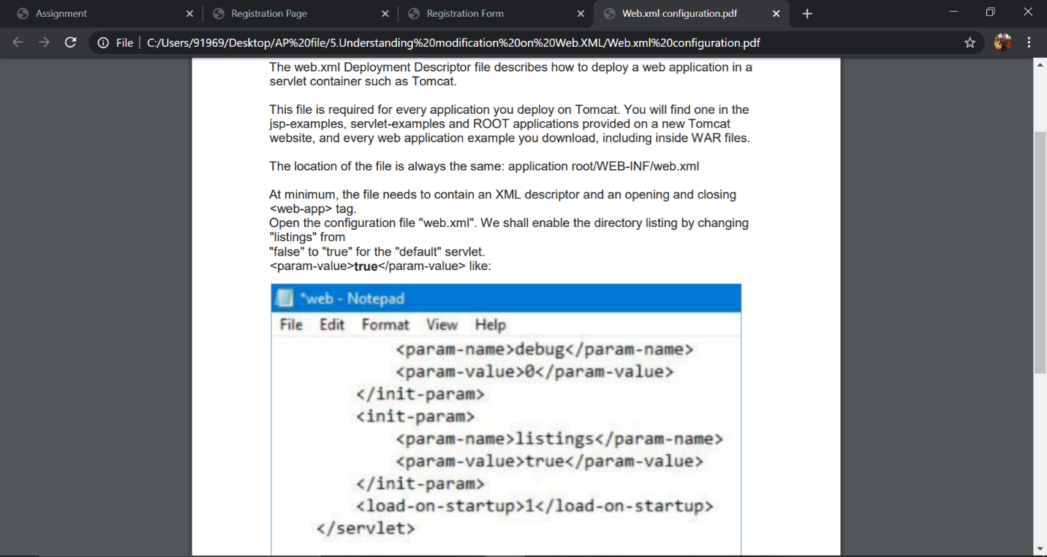

1. **Aim: Creating a website using PHP.**

**CODE:**

1. **about.html**

<!DOCETYPE html>

<html>

<head>

<style >

a

{ text-decoration :none;}

body {

background-image: url("4.jpg");

background-repeat: no-repeat;

background-color: aqua;

background-size: cover;

}

div{

color: white;

}

</style>

</head>

<body>

<a href="mailto:programeeez@abc.com?subject=feedback">Email Us</a>

<br>

<br>

<div >

<footer>

<address>

Ghaziabad, UttarPradesh

245304

</address>

</footer>

</div>

</body>

</html>

**OUTPUT:**

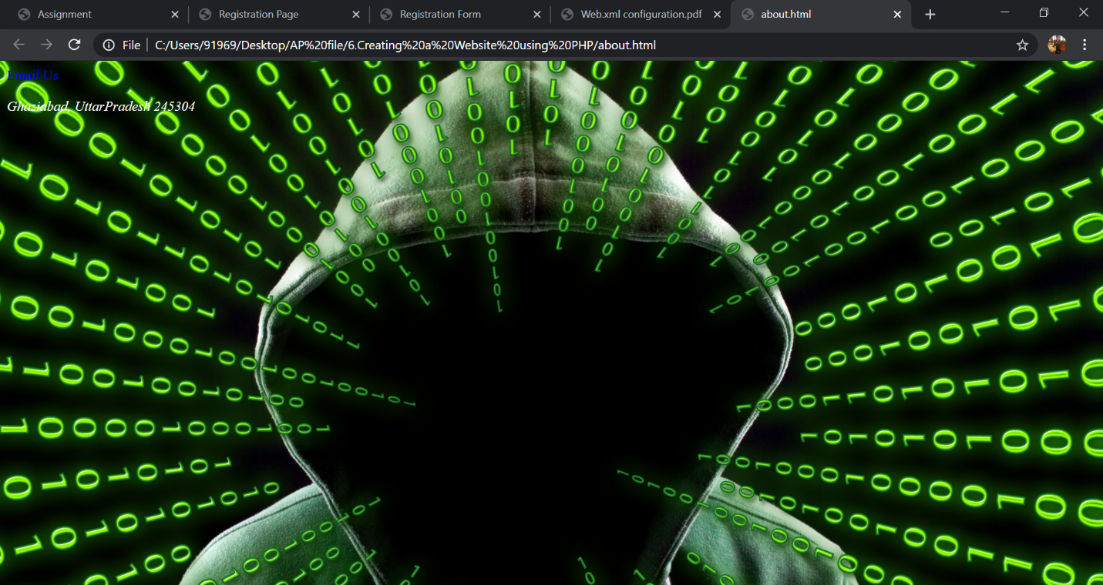

1. **body.html**

<!DOCTYPE html>

<html lang="en" dir="ltr">

<head>

<style>

.mySlides {display:none;}

</style>

</head>

<body style="background-color:#DDDDDD;">

<div style="max-height:800px">

<img class="mySlides" src="1.jpg" style="width:100%">

<img class="mySlides" src="2.jpg" style="width:100%">

<img class="mySlides" src="3.jpg" style="width:100%">

<img class="mySlides" src="4.jpg" style="width:100%">

<img class="mySlides" src="5.jpg" style="width:100%">

<img class="mySlides" src="6.jpg" style="width:100%">

</div>

<script>

var myIndex = 0;

carousel();

function carousel() {

var i;

var x = document.getElementsByClassName("mySlides");

for (i = 0; i < x.length; i++) {

x[i].style.display = "none";

}

myIndex++;

if (myIndex > x.length) {myIndex = 1}

x[myIndex-1].style.display = "block";

setTimeout(carousel, 2000); // Change image every 2 seconds

}

</script>

</body>

</html>

**OUTPUT:**

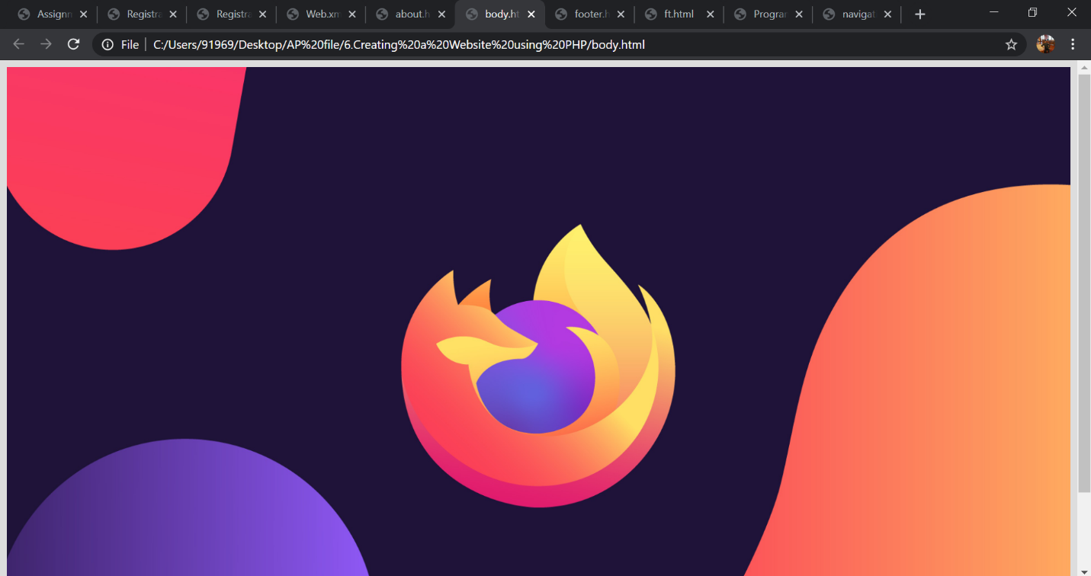

1. **footer.html**

<!DOCTYPE html>

<html>

<head>

<style media="screen">

body{

display: block;

color: #111111;

text-align: left;

padding: 14px 16px;

text-decoration: none;

background-color: aqua;

}

</style>

</head>

<body>

<div >

<footer>

<address>

<h2><b>

Ghaziabad, Uttar Pradesh

245304

</b></h2>

</address>

</footer>

</div>

</body>

</html>

**OUTPUT:**

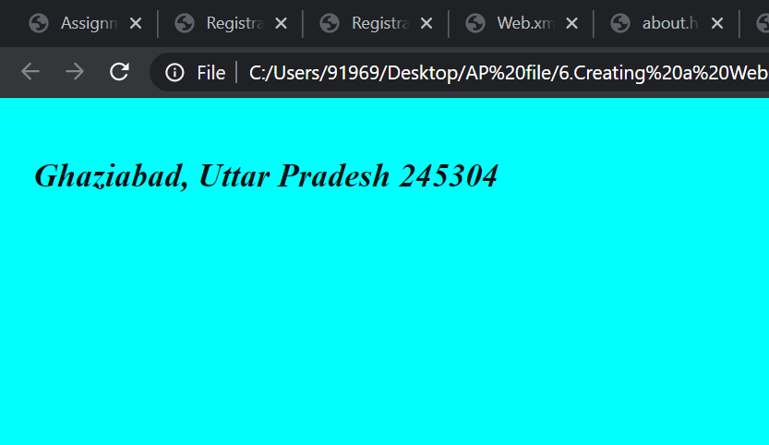

1. **ft.html**

<!DOCTYPE html>

<html>

<head>

<style media="screen">

body{

background-image: url("2.jpg");

background-repeat: no-repeat;

background-size : cover;

display: block;

color: white;

text-align: left;

padding: 14px 16px;

text-decoration: none;

}

</style>

</head>

<body>

<div >

<p><pre><b><i>

Programeeez is optimized for learning, testing, and training.Examples might be simplified to improve reading and basic understanding.

Tutorials, references, and examples are constantly reviewed to avoid errors, but we cannot warrant full correctness of all content.

While using this site, you agree to have read and accepted our terms of use, cookie and privacy policy.

Copyright 2020. All Rights Reserved.</i>

</b>

</pre>

</p>

</div>

<div >

<footer>

<address>

Ghaziabad, Uttar Pradesh

245304

</address>

</footer>

</div>

</body>

</html>

**OUTPUT:**

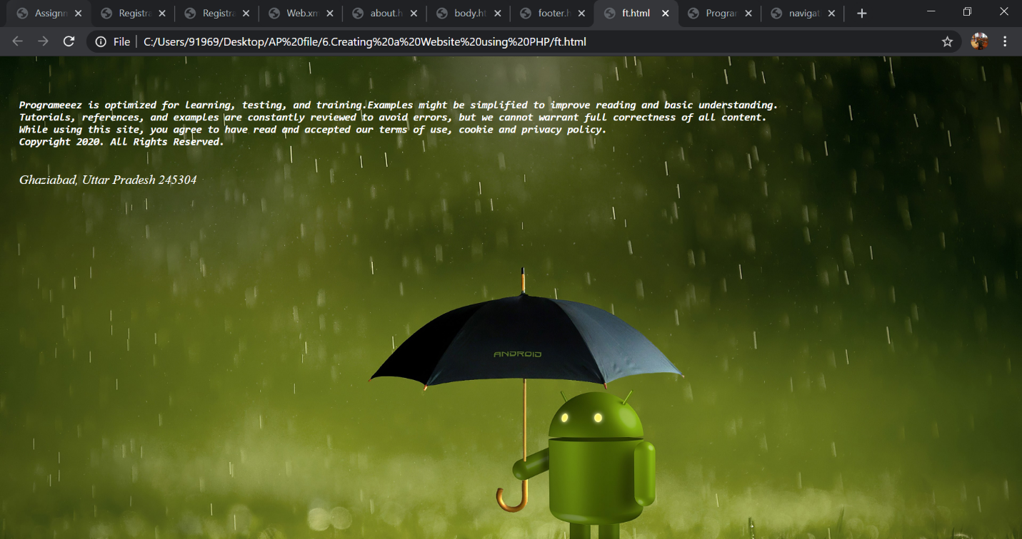

1. **header.html**

<!DOCTYPE html>

<html>

<head>

<title>Programeeez</title>

</head>

<body>

<div >

<img src="logo.jpg" alt="logo" width="100%" height="100px;">

</div>

</body>

</html>

1. **navigation.html**

<!DOCTYPE html>

<html>

<head>

<style>

.top {

overflow:hidden;

background-color: crimson;

width : 100%;

}

.top a {

float: left;

display: block;

color: black;

text-align: center;

padding: 30px 16px;

text-decoration: none;

}

.top a:hover {

background-color:blue;

color: black;

}

</style>

</head>

<body>

<div class="top">

<h2>

<a href="index.php">Home</a>

<a href="about.php">About Us</a>

<a href="contact.php">Contact Us</a>

</h2>

</div>

</body>

</html>

**OUTPUT:**

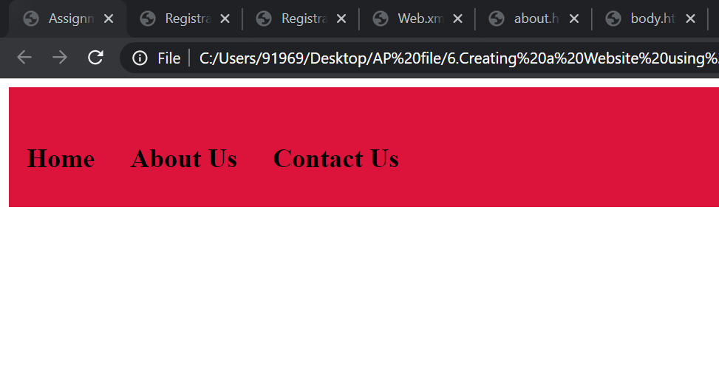

1. **about.php**

<?php echo file_get_contents("header.html");?>

<?php echo file_get_contents("navigation.html");?>

<?php echo file_get_contents("ft.html");?>

1. **contact.php**

<?php echo file_get_contents("header.html");?>

<?php echo file_get_contents("navigation.html");?>

<?php echo file_get_contents("about.html");?>

1. **index.php**

<?php echo file_get_contents("header.html");?>

<?php echo file_get_contents("navigation.html");?>

<?php echo file_get_contents("body.html");?>

<?php echo file_get_contents("footer.html");?>

**OUTPUT:**

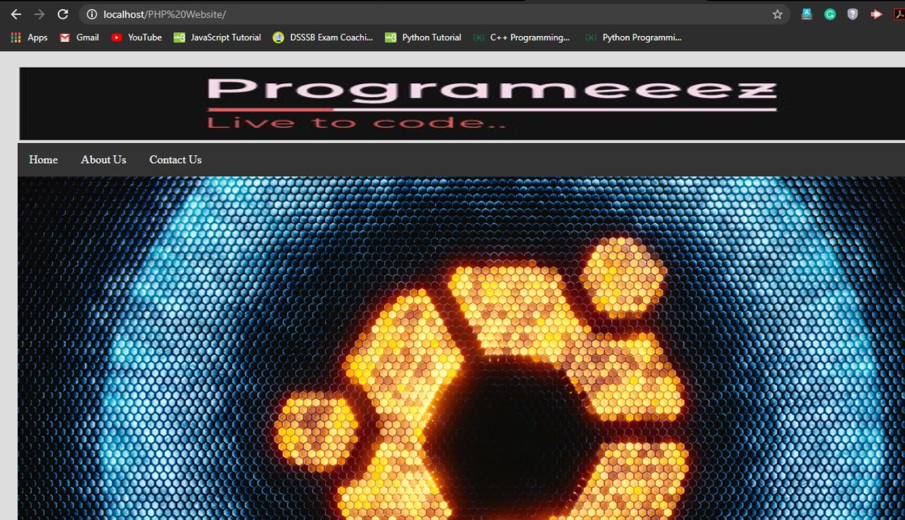

1. **Aim: Understanding Java script.**

**CODE:**

<!DOCTYPE html>

<html>

<head>

<title>Java Scripts</title>

<script type="text/javascript">

function validate()

{

var username=document.getElementById("uname").value;

var regx=/A00/;

if(regx.test(username))

{

alert("Valid Username");

}

else

{

alert("Invalid Username");

}

}

</script>

</head>

<body>

<form action="message.html">

<input type="text" id="uname" placeholder="username"/>

<button onclick="validate()">Submit</button>

</form>

</body>

</html>

**OUTPUT:**

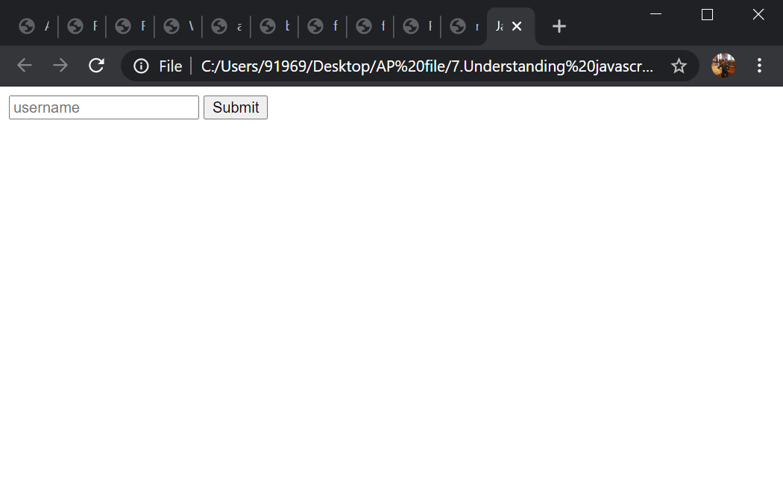

1. **Creating Web page with back end in PHP and front end in Java script and hosting it on Apache Tomcat server Code:**

**CODE:**

1. **form.html**

<!DOCTYPE html>

<html>

<head>

<title>PHP Server Side Form Validation and JAVASCRIPT client side validation</title>

<script src="https://ajax.googleapis.com/ajax/libs/jquery/2.2.0/jquery.min.js"></script>

<link rel="stylesheet" href="https://maxcdn.bootstrapcdn.com/bootstrap/3.3.6/css/bootstrap.min.css" />

<script src="https://maxcdn.bootstrapcdn.com/bootstrap/3.3.6/js/bootstrap.min.js"></script>

<script type="text/javascript">

document.getElementById("registerbtn").addEventListener("click",function(e){

var fieldValue=document.getElementById("name").value;

if(fieldValue==null || fieldValue== ""){

e.preventDefault();

alert("you must enter a username");

}

});

</script>

</head>

<body>

<br />

<div class="container" style="width:500px;">

<h3 class="text-center">PHP Server Side Form Validation and JAVASCRIPT client side validation</h3>

<form method="POST" action="http://localhost/AP/form.php" name="regform" onsubmit="return validate()">

<div class="form-group">

<label>Enter Name<span class="text-danger">*</span></label>

<input type="text" name="name" id="name" class="form-control" maxlength="75" />

<span class="text-danger"><?php echo $name_error; ?></span>

</div>

<div class="form-group">

<label>Enter Email<span class="text-danger">*</span></label>

<input type="text" name="email" class="form-control" maxlength="150" />

<span class="text-danger"><?php echo $email_error; ?></span>

</div>

<div class="form-group">

<label>Select Gender<span class="text-danger">*</span></label>

<div class="radio">

<input type="radio" name="gender" value="Male" />Male

</div>

<div class="radio">

<input type="radio" name="gender" value="Female" />Female

</div>

<span class="text-danger"><?php echo $gender_error; ?></span>

</div>

<div class="form-group">

<button type="submit" name="submit" id="registerbtn" value="Submit" class="btn btn-info">Submit</button>

</div>

</form>

<div><?php echo $output; ?></div>

</div>

<br/>

</body>

</html>

1. **form.php**

<?php

$name_error = '';

$email_error = '';

$gender_error = '';

$output = '';

if(isset($_POST["submit"]))

{

if(empty($_POST["name"]))

{

$name_error = "<p>Please Enter Name</p>";

}

else

{

if(!preg_match("/^[a-zA-Z ]*$/", $_POST["name"]))

{

$name_error = "<p>Only Letters and whitespace allowed</p>";

}

}

if(empty($_POST["email"]))

{

$email_error = "<p>Please Enter Email</p>";

}

else

{

if(!filter_var($_POST["email"], FILTER_VALIDATE_EMAIL))

{

$email_error = "<p>Invalid Email format</p>";

}

}

if(empty($_POST["gender"]))

{

$gender_error = "<p>Please Enter your Gender</p>";

}

if($name_error == "" && $email_error == "" && $gender_error == "")

{

$output = '<p><label>Ouput-</label></p>

<p>Your Name is '.$_POST["name"].'</p>

<p>Your Email is '.$_POST["email"].'</p>

<p>Your Gender is '.$_POST["gender"].'</p>

';

}

}

?>

**OUTPUT:**

